How to create a resume repository using Git-bash & Git-hub  
  
Step 1. Create a New file or directory on your computer Desktop and name it “My resume”

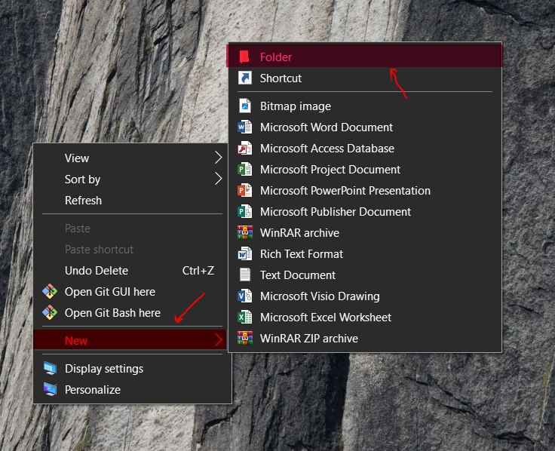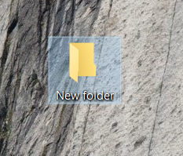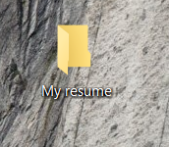

Step 2: Open the folder, right click and Open Git-bash here, a new window will open   
“MINGW64:/c/Users/lenovo/Desktop/My resume”--- for example  
  
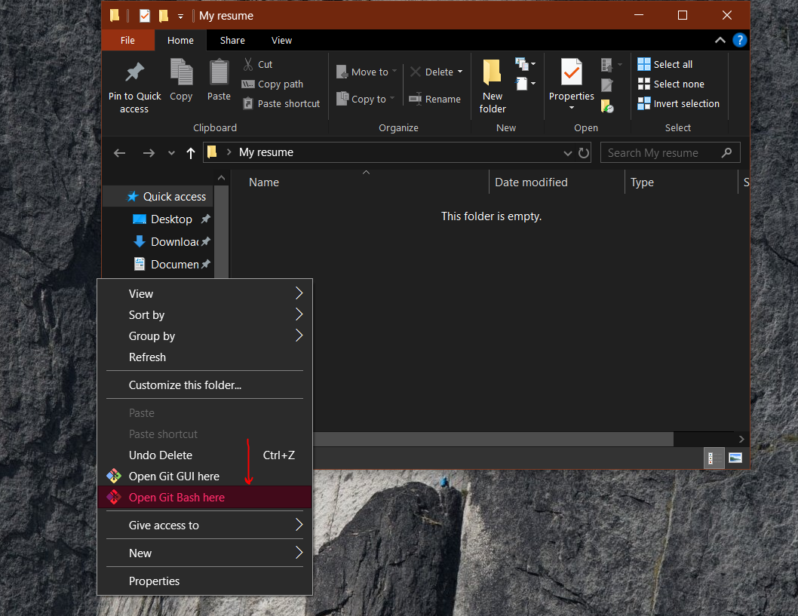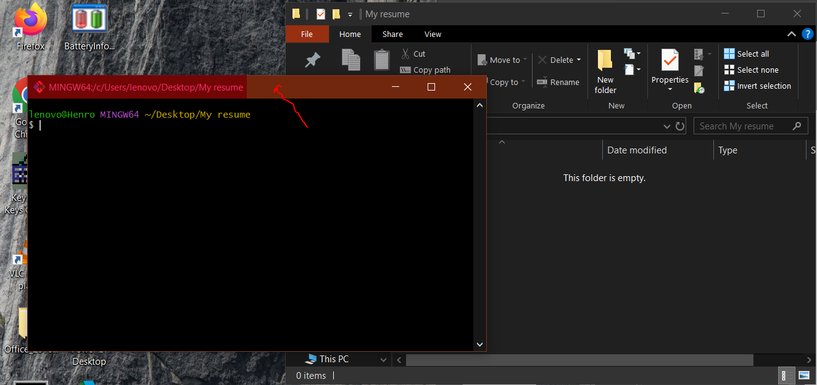

Step 3: Create a text file by entering the command  
“cd touch file1” 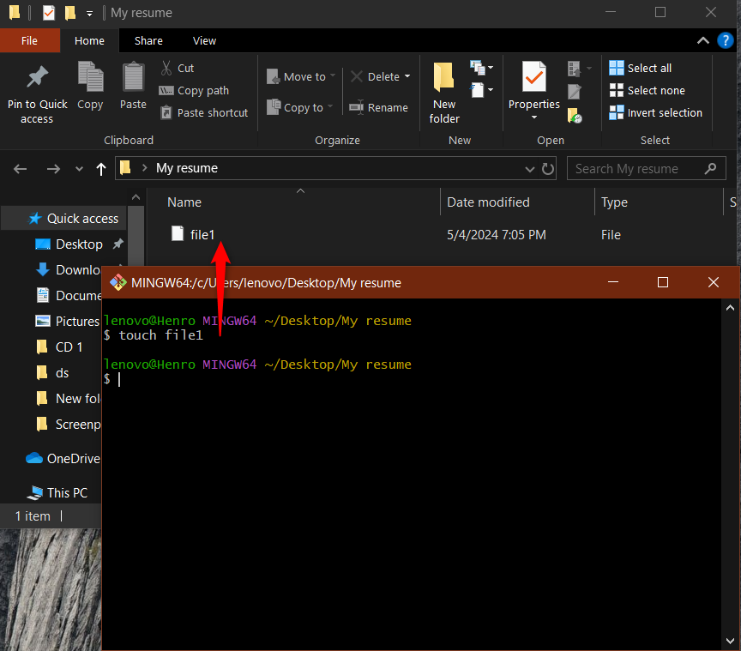

Step 4 : Get a sample Index.html resume from chatgpt and copy the code

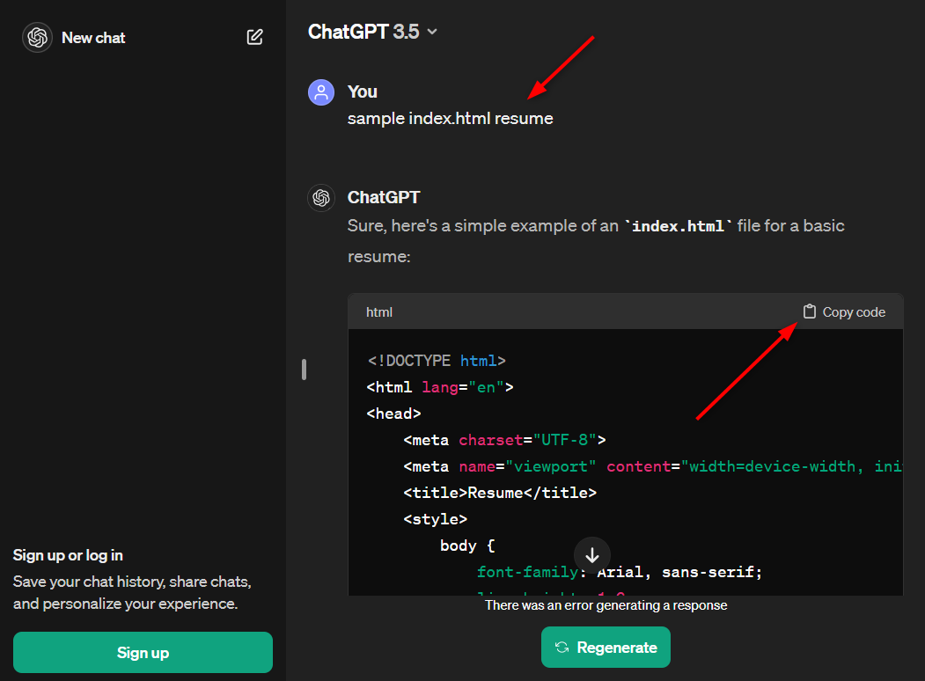

Step 5 : On your Git-bash, Enter the command   
  
“vim file1” – To enter the file for editing

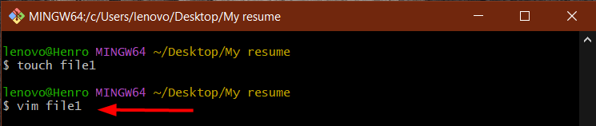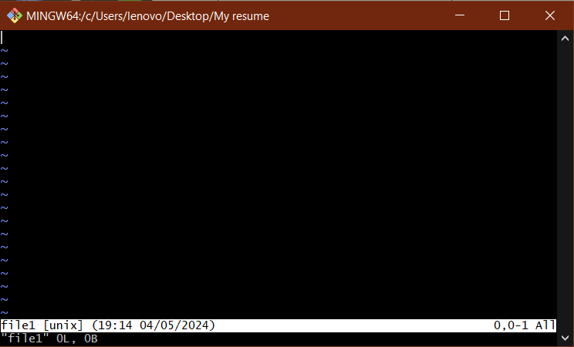

“Press ‘I’ “ – To insert a text or code such as the Index.html sample resume 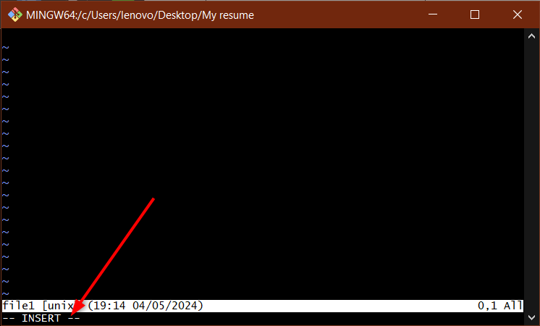

Insert the index.html code from chatgpt

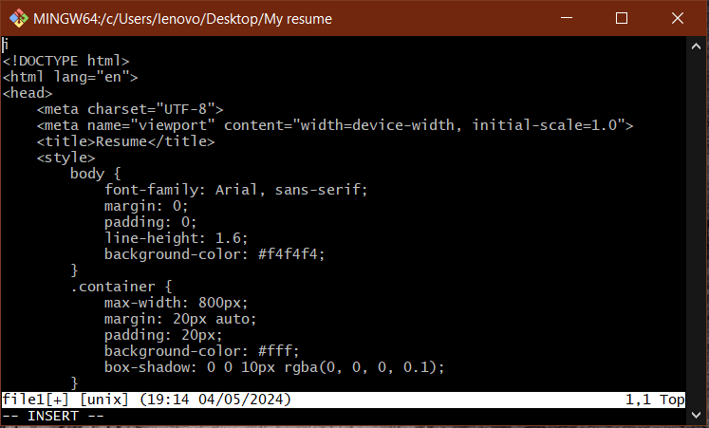

Press “ESC” – To stop inserting  
Press “Shift+ colon(:)” – to end the process  
Press “ W” – To save your work or “wq” --- To save and exit the file.

Then press “enter” to take you back to bash.

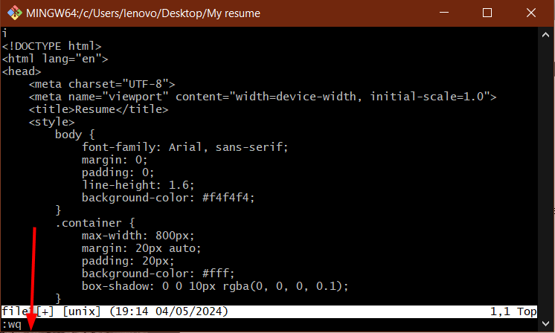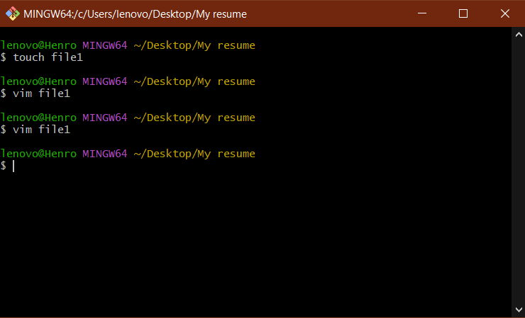

Step 6: Configure your identity in git-bash

Enter the command – “git config – global user.name “Name”

Then press enter

Enter the command – “git config – global user.email “email”

Then press enter

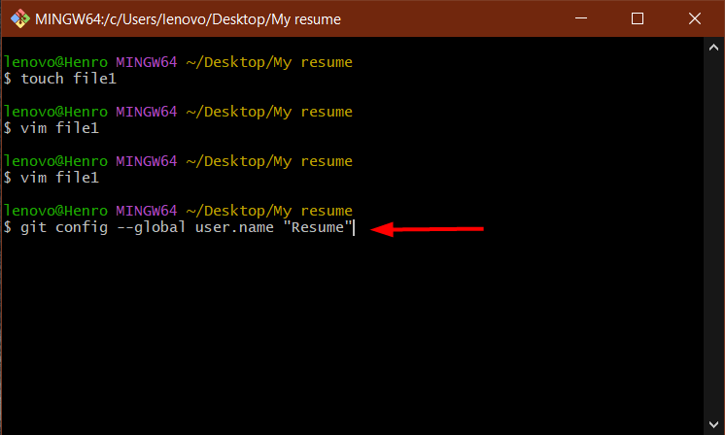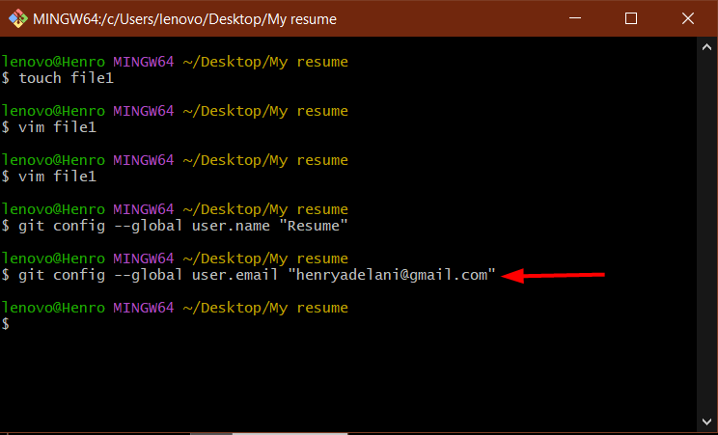

Step 7 : Initialize the git file   
Enter the command “git init”

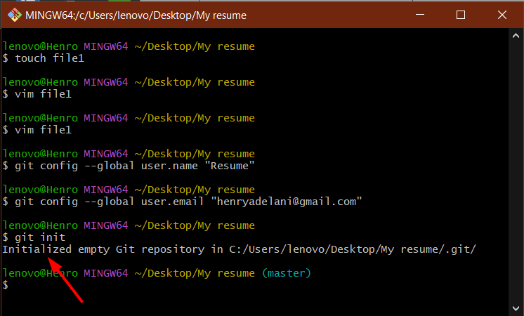

Step 8: Go to your github account, login and find the “+” on the top right corner and create a new repository

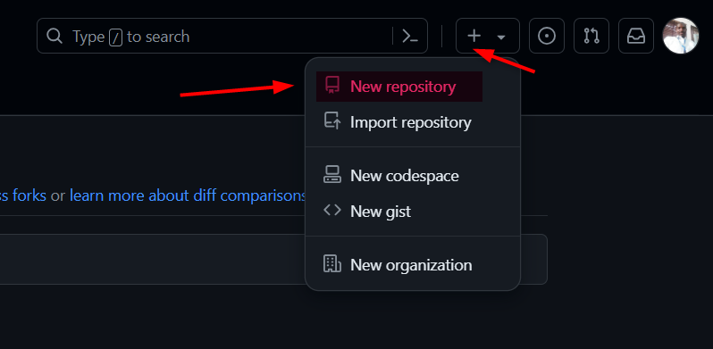

Give it a name “ Resumerepo” and click “create repository”

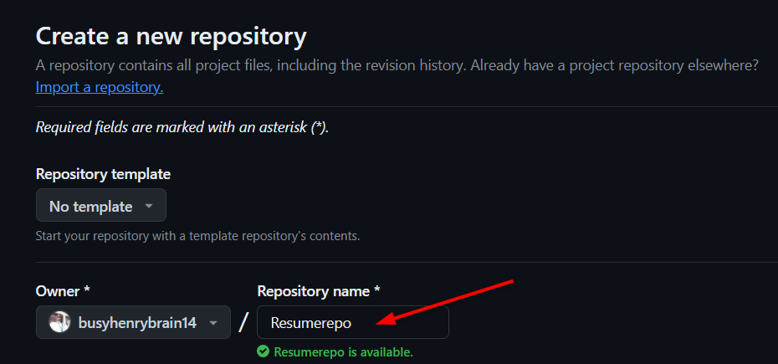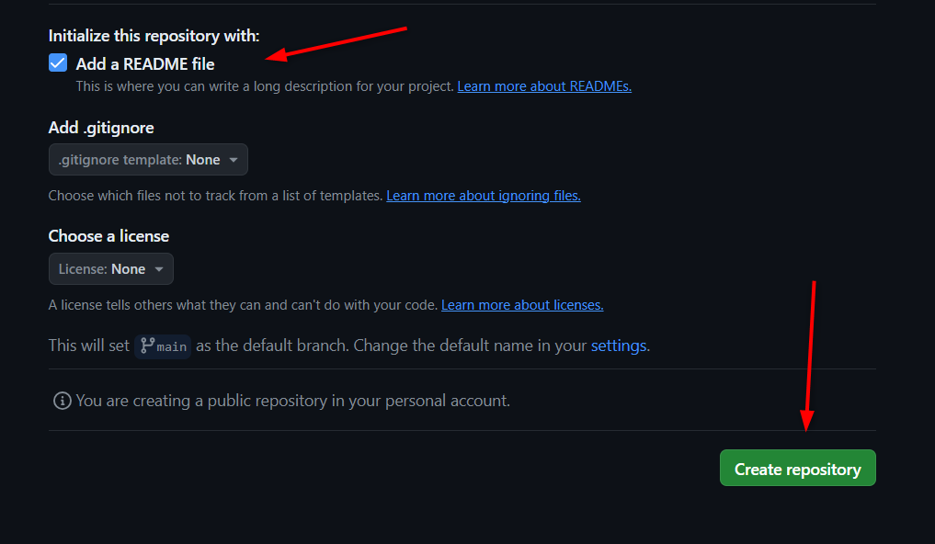

Next, Click on the “Code button” and copy the “HTTPS Code”

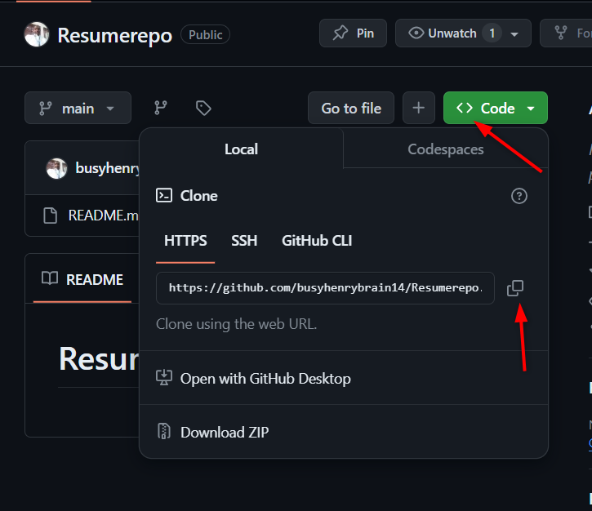

Step 9 : Git Clone   
  
Enter the command – “git remote add origin “(insert the HTTPS code from github here)”

Enter the command – “git remote add origin <https://github.com/busyhenrybrain14/Resumerepo.git>

Press Enter

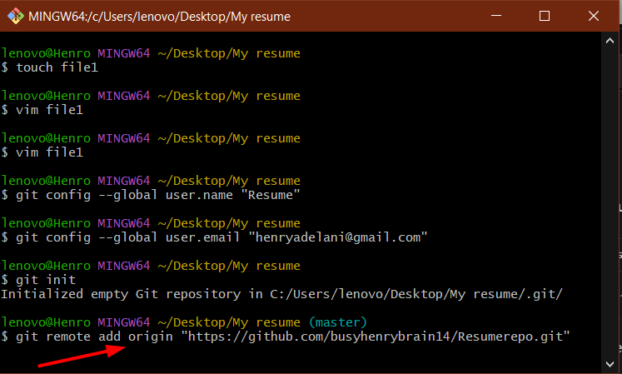 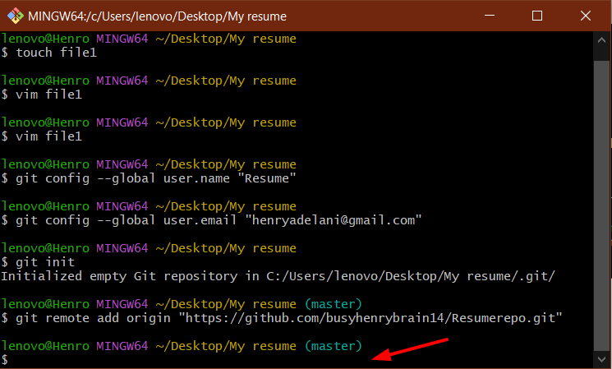

Lets Check the status of our file so far

Enter the command – “ git status”

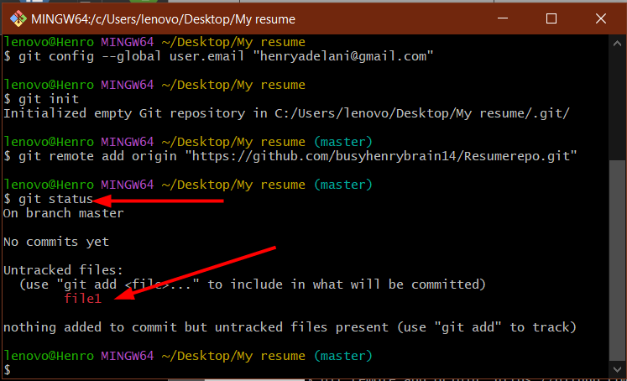

Untracked files tells us that Git can’t track our file , we need to add it to a staging area to track the file

Enter the command – “git add .” and check the status again by entering “git status” 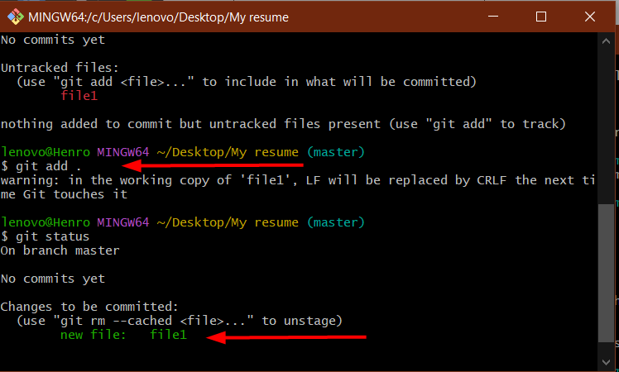

Now our file is staged.

Step 10: Commit our file to prepare it to be sent to github

Enter the command – “ git commit –m “(commit comment)”

Enter the command – “ git commit –m “Commiting Resumepo” 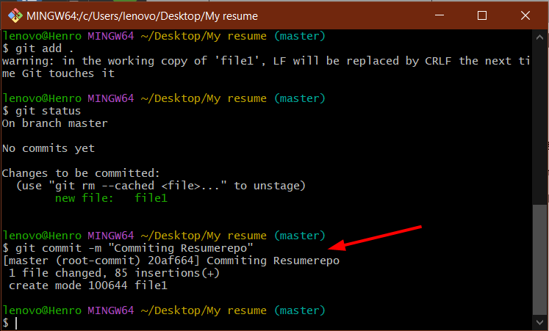

Now push to Git-hub

Enter the command --- “git push origin master” 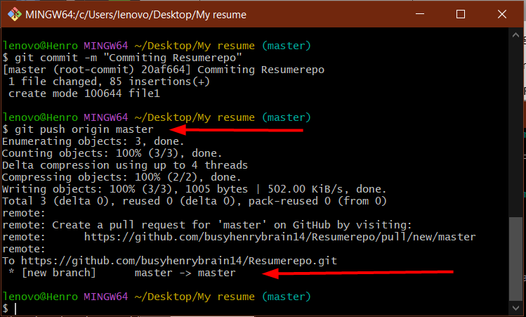

Go back to Github and click “ compare & pull request”

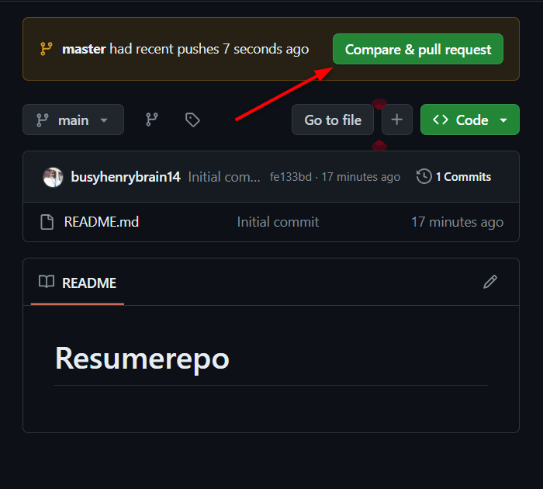

Congratulations your resumerepo is on github

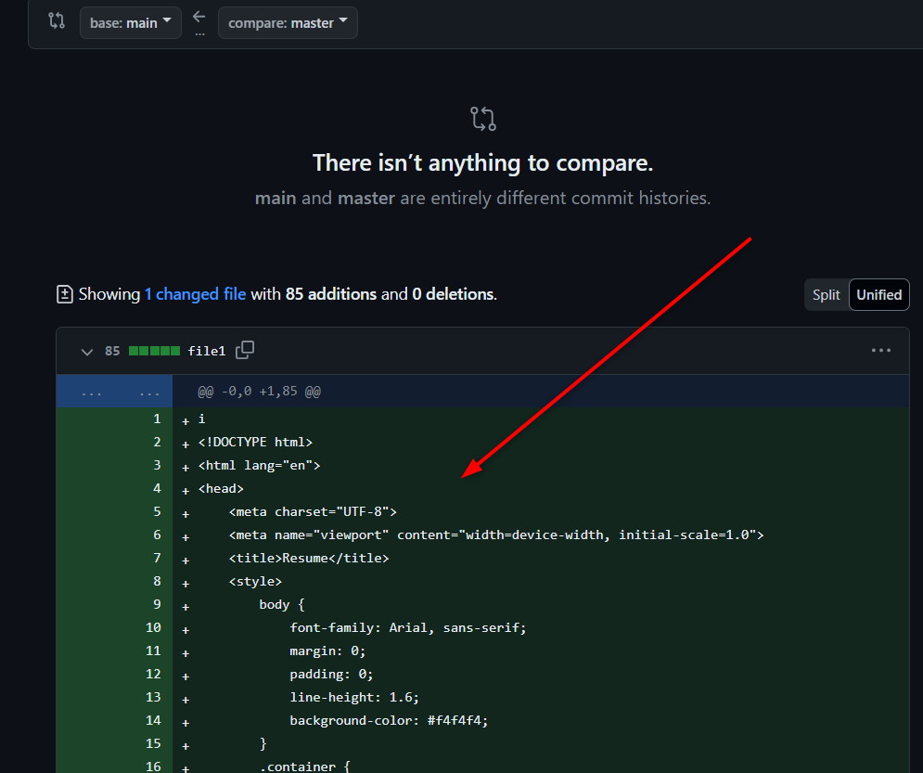

Back on your desktop folder , open the folder and the file to see your “Index.html resume code” and confirm with the one on Github

